Novel and play 17

First director: Duke of Saxe-Meiningen (19th century)

Arena stage ↔ proscenium stage

Pre-rehearsal

Choosing a play

Choosing the team
Casting and audition

Working on the script

Moves and blocking

The rehearsal period

The first rehearsal
The read-through
Weeks
The technical rehearsal
The first dress rehearsal
First preview
Opening night

Questions to think about:
- The meaning of the play
- How do we choose a play?
- The floor plan: symmetrical or asymmetrical? What else about the composition of the furniture?
- Why should the set designer avoid long straight lines?
- Have the one who seem to understand the play and read it with some ease, or the one who has the look, the voice, or the personality? Why? Of course, we need the one who can fit with the rest of the cast. Why do we need those who can gain a lot from this acting experience, emotionally?
- Which one is better? A head actor (one who is technically brilliant, but cannot move the audience) or a heart actor (one who moves the audience to tears)?
- What should the remaining actors do when one actor moves away from the grouping of three or more?
- Exit line: how to avoid a meaningless pause as the actor exits?
- How to have an actor develop his character?
- How to offer direction to an actor when you find an acting problem?
- How to avoid neglecting those who have developed their characters quickly and now get no attention from you?
- What do we do when an actor reads every line alike? When he rush lines? How to help an actor be more natural?
- What do we do with actors who have been on stage for a long period of time but has little to say? (How to help them stay in character?)
- Prompter or no prompter?
- What do we do suppose an emergency should occur to an actor, and now the play is to start in 30 minutes?
- Which is better? To tell the actors how they should move or have them decide for themselves during rehearsal?

THE IMPORTANCE OF BEING EARNEST (from Braham Murray↔objective, Stanislavski)

ALGERNON: How are you, my dear Ernest? What brings you up to town?
JACK: Oh, pleasure, pleasure! What else should bring one anywhere?

Beat 1
Algernon’s objective is to make Jack feel at home.
Jack’s objective is to get the upper hand. Algernon always makes him feel slightly inferior.
Eating as usual, I see, Algy!

ALGERNON: (Stiffly.) I believe it is customary in good society to take some slight refreshment at five o’clock.

Beat 2
Jack’s objective is to make Algernon feel in the wrong. Algernon’s to defend himself.
Where have you been since last Thursday?

JACK: (Sitting down on the sofa.) In the country.

Beat 3
Algernon’s objective is to find out where Jack has been. Jack’s objective is to tell him.

ALGERNON: What on earth do you do there?
JACK: (Pulling off his gloves.) When one is in town one amuses oneself. When one is in the country one amuses other people. It is excessively boring.

Beat 4
Algernon’s objective is to find out about Jack in the country. Jack’s objective is to fob him off, as this life is secret.

Shakespeare

Music, awake her; strike!
‘Tis time; descend; be stone no more; approach;
Strike all that look upon with marvel. Come
I’ll fill your grave up: stir, nay, come away:
Bequeath to death your numbness; for from him
Dear life redeems you. You perceive she stirs.

(X) Blocking actors

(√)

(X)

↓

(√)

Open turn and closed turn

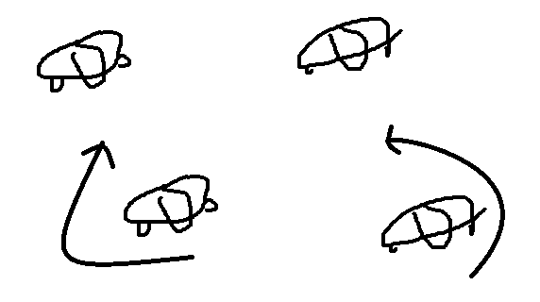

Downstage Cross and upstage cross

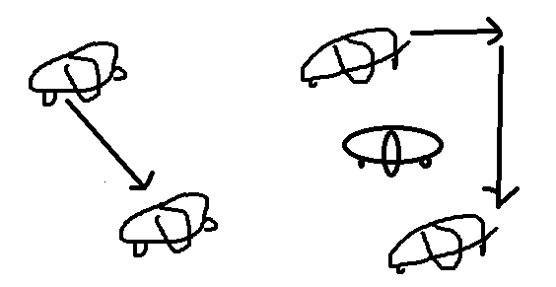

Countering to dress the stage

