Emilie Lee
S10427041
Writing
Professor Pierre Hsu

A Picture aAbout my Nervous Experience
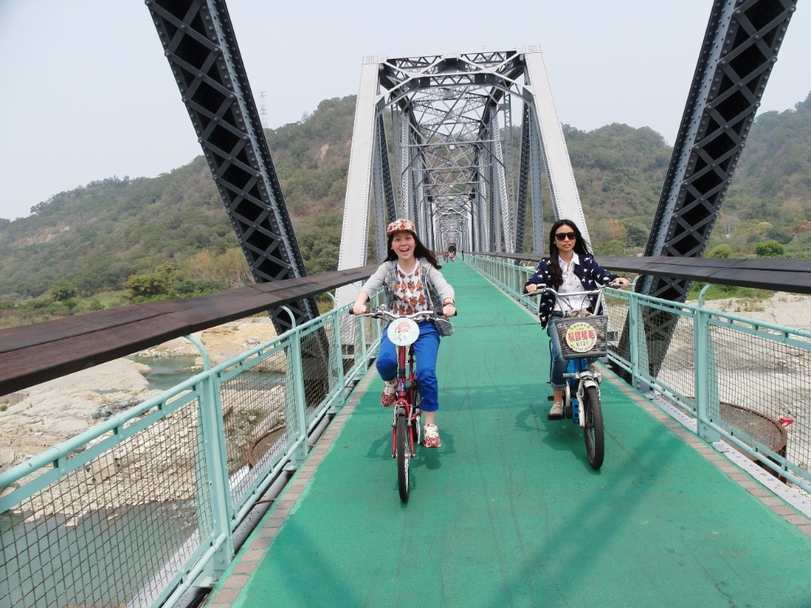
I was extremely nervous for having achieved finishing a great progress in my life when this picture was taken. Then, I was pedaling bicycling on a bike path with my friends, and we were crossing an elevated bridge from one hill to another. Although I seemed to wear have a big smile on my face, actually, I was screaming loudly. Being quite intense, I was that of my cap would be blown off or I would fell down off the bridge because owing to the place there was windy and the water flow below the structure was really rapid so I could hear the sound of splash clearly which made me more nervous. Moreover, the bridge was so long that I thought I had spent an hour crossing it as it just cost me about ten minutes actually. Instead of screaming intensely, my friend besides me was claimed and finished crossing the structure faster than I in the end. As a result, it is a memorable photo that can remind me of having finished a difficult work to encourage me when I was depressed.

- Wordy, so that sometimes the sentences become quire awkward.
- Topic sentence good.
- Some mistakes in grammar.
- Grade: 74

