Zheyu kuo
S10427003
Writing
Professor Pierre Hsu

A Photo of my Childhood The photo of my childhood

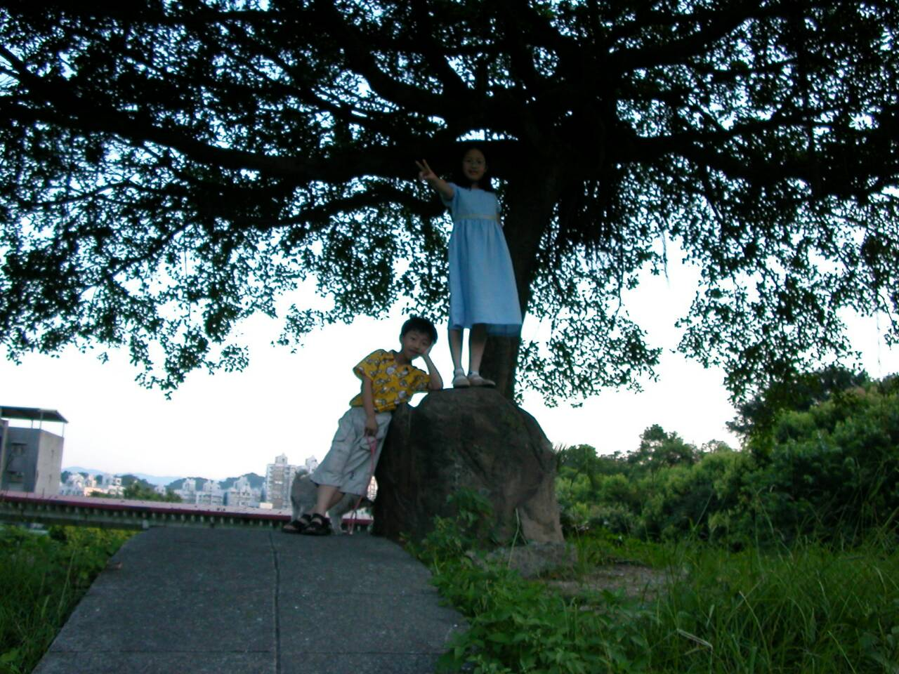

This picture is a shot of by my parents, on the hill near my aunt’s house of in Keelung where I had stayed until I grew up to be able to go to the elementary school. At the moment, I was a cute boy wearing a yellow shirt and the dots of Miki Mouse with the handsome baby face. This outfit made me the focus, outshining more obvious even covered the little blue girl in blue beside me. She is my cousin sister older than me by one year old. We had often been there playing a lot of games, for example: “Red Light & Green Light” or “ Hide_and_ Seek”. Although the other people would seem to be no where can hide, the truth was we usually hid very well, and the Seekers almost wept because they could not find the Hider. However, we were different from the past our past selves. We meant to play the drama called “The Queen and the Eunuch “. Because of the stone is her sedan chair and I just only was assigned for the eunuch of responsible the dog behind me.

- From the sixth line on, the writing becomes irrelevant to the topic.
- There is no unifying impression in this writing.
- Grade: 63-5 (late)

